**Mini Project – Retail Sales**

**Business Questions:**

* **Understand sales distribution: Which product categories are most profitable?**

**Category**

|  |  |
| --- | --- |
| **Furniture** | 404251.04 |
| **Office Supplies** | 362634.69 |
| **Technology** | 349755.87 |

**Furniture** is the Category most Profit and Best Seller as Subcategory Chairs were purchased most.

* **Regional performance: Which region performs best in terms of sales?**

|  |  |
| --- | --- |
| Region | Sales |
| East | 1840845 |
| North | 1961738 |
| South | 1838119 |
| West | 1854004 |

|  |  |
| --- | --- |
| Region | Profit |
| East | 266883.24 |
| North | 291369.41 |
| South | 279152.36 |
| West | 279236.59 |

By Looking at the Table, we conclude that most Profit and Sales Performs in **North Region.**

* **Profitability insights: Are higher sales always leading to higher profits?**

Yes, The Sale in the North is higher than other region also comparing with higher profit North moves top

* **Seasonal trends: Which months show seasonal spikes in sales?**

|  |  |
| --- | --- |
| Month | Sales |
| 1 | 623691 |
| 2 | 619136 |
| 3 | 588829 |
| 4 | 648805 |
| 5 | 704472 |
| 6 | 560443 |
| 7 | 683232 |
| 8 | 636074 |
| 9 | 643423 |
| 10 | 556354 |
| 11 | 636250 |
| 12 | 593997 |

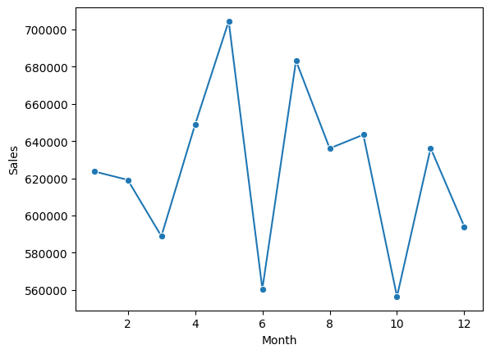

* **Customer trends: Identify frequent customers and their contribution to revenue.**

|  |  |
| --- | --- |
| **CustomerID** | **Frequent Purchase Times** |
| CUST029 | 15 |
| CUST059 | 14 |
| CUST293 | 13 |
| CUST434 | 12 |
| CUST104 | 12 |
| CUST408 | 11 |
| CUST439 | 11 |
| CUST047 | 11 |
| CUST336 | 11 |
| CUST472 | 11 |
| CUST334 | 11 |
| CUST107 | 11 |
| CUST435 | 11 |
| CUST234 | 11 |
| CUST181 | 11 |
| CUST320 | 11 |
| CUST344 | 11 |
| CUST063 | 11 |
| CUST441 | 11 |
| CUST143 | 11 |

|  |  |
| --- | --- |
| **CustomerID** | **Total Purchase of the Customer** |
| CUST472 | 45505 |
| CUST439 | 40263 |
| CUST343 | 39751 |
| CUST059 | 37680 |
| CUST353 | 35517 |
| CUST321 | 35303 |
| CUST434 | 34919 |
| CUST226 | 33408 |
| CUST408 | 33236 |
| CUST409 | 32429 |

By Looking at the table, we able to see that most CUST029 is not in the Total Purchase table, may be he will be bought few amount of products frequently, but if we look at the frequent customers list most of them were contributed higher in revenue, so based on our customer

**Project Summary:**

From the retail sales analysis, we observed that Furniture is the most profitable category, with Chairs being the best-selling subcategory. Among regions, the North region performed the best in both sales and profit, while the South and East regions lag slightly behind. Seasonal trends indicate May and July as peak months, highlighting clear sales spikes. Customer insights show that while some customers, like CUST029, purchase frequently in smaller amounts, many frequent buyers also contribute significantly to overall revenue, making them key drivers of business growth.

Looking ahead, the plan should focus on strengthening the North region by ensuring better stock availability, premium offerings, and loyalty programs for top customers. To improve lower-performing regions, targeted promotions, optimized product selection, and stronger distribution strategies should be adopted. Preparing for peak months in advance will capture maximum seasonal demand. Overall, by leveraging high-performing regions and customers while uplifting weaker areas, the business can achieve stronger growth and profitability in the coming year.